|  |  |  |  |
| --- | --- | --- | --- |
|  | **Bansilal Ramnath Agarwal Charitable Trust's**  **Vishwakarma Institute of Information Technology**  **Department of**  **Artificial Intelligence and Data Science** | | |
| Student Name: Siddhesh Dilip Khairnar | | | |
| Class: S.Y. | Division: B | | Roll No: 272028 |
| Semester: IV | | Academic Year: 2022 - 23 | |
| Subject Name & Code: Advanced Data Structures: ADUA22202 | | | |
| Title of Assignment: Write a program to construct an expression tree from postfix/prefix expression and perform In-order, pre-order and post-order traversals. | | | |
| Date of Performance: 1/02/2023 | | Date of Submission: 10/02/2023 | |



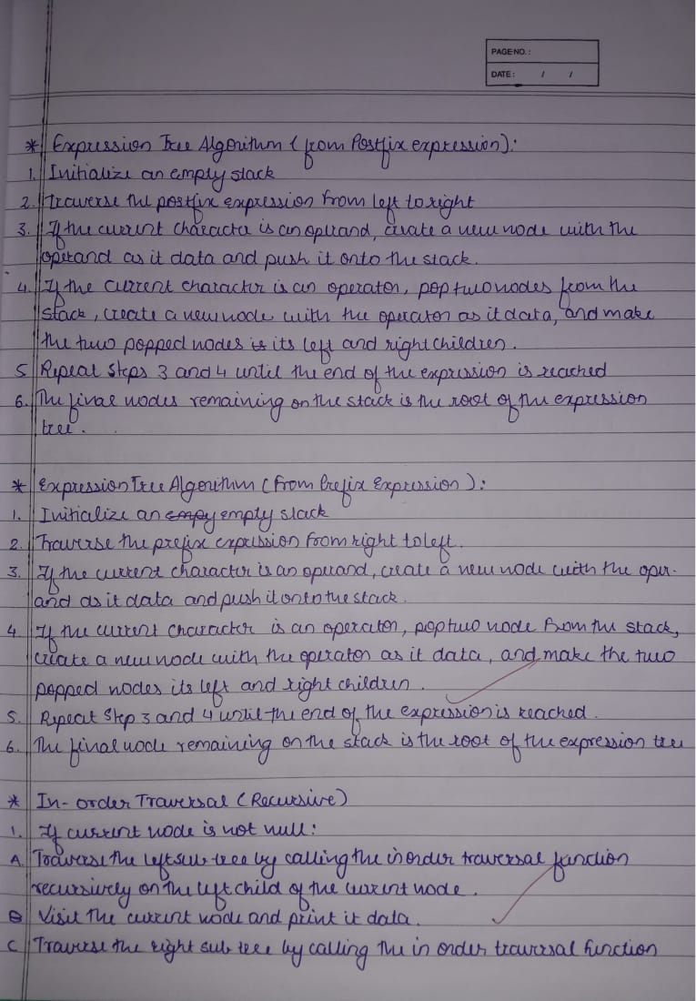

**CODE AND OUTPUT**

#include <iostream>

#include <stack>

#include <string>

using namespace std;

class Node

{

public:

    Node *left;

    Node *right;

    char value;

    Node(char value)

    {

        this->value = value;

        this->left = NULL;

        this->right = NULL;

    }

};

bool is_operand(char c)

{

    if ((c >= 'a' && c <= 'z') || (c >= 'A' && c <= 'Z'))

    {

        return true;

    }

    return false;

}

Node *build_tree(std::string expression, bool is_postfix)

{

    std::stack<Node *> stack;

    for (int i = 0; i < expression.length(); i++)

    {

        char c = expression[i];

        if (is_operand(c))

        {

            stack.push(new Node(c));

        }

        else

        {

            Node *node = new Node(c);

            if (is_postfix)

            {

                node->right = stack.top();

                stack.pop();

                node->left = stack.top();

                stack.pop();

            }

            else

            {

                node->left = stack.top();

                stack.pop();

                node->right = stack.top();

                stack.pop();

            }

            stack.push(node);

        }

    }

    return stack.top();

}

void in_order_traversal(Node *root)

{

    if (root != NULL)

    {

        in_order_traversal(root->left);

        std::cout << root->value << " ";

        in_order_traversal(root->right);

    }

}

void pre_order_traversal(Node *root)

{

    if (root != NULL)

    {

        cout << root->value << " ";

        pre_order_traversal(root->left);

        pre_order_traversal(root->right);

    }

}

void post_order_traversal(Node *root)

{

    if (root != NULL)

    {

        post_order_traversal(root->left);

        post_order_traversal(root->right);

        cout << root->value << " ";

    }

}

int main()

{

    string expression = "ab+ef*g*-";

    Node *root = build_tree(expression, false);

    cout << "In-order: ";

    in_order_traversal(root);

    cout << endl;

    cout << "Pre-order: ";

    pre_order_traversal(root);

    cout << endl;

    cout << "Post-order: ";

    post_order_traversal(root);

    cout << endl;

    return 0;

}

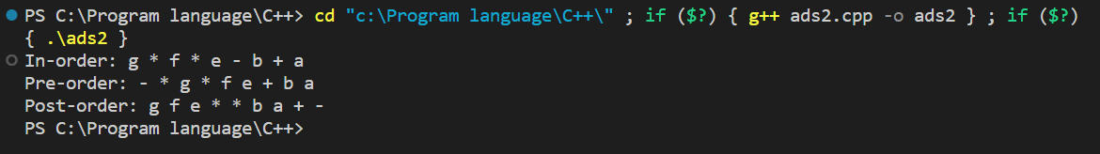

Conclusion: Successfully implemented program for expression tree from postfix/prefix expression and perform In-order, pre-order and post-order traversals.